CH. Naveen

192111560

1. Configuration of Network Devices using Packet Tracer 192111560 tools (Hub, Switch, Ethernet, Broadcast)

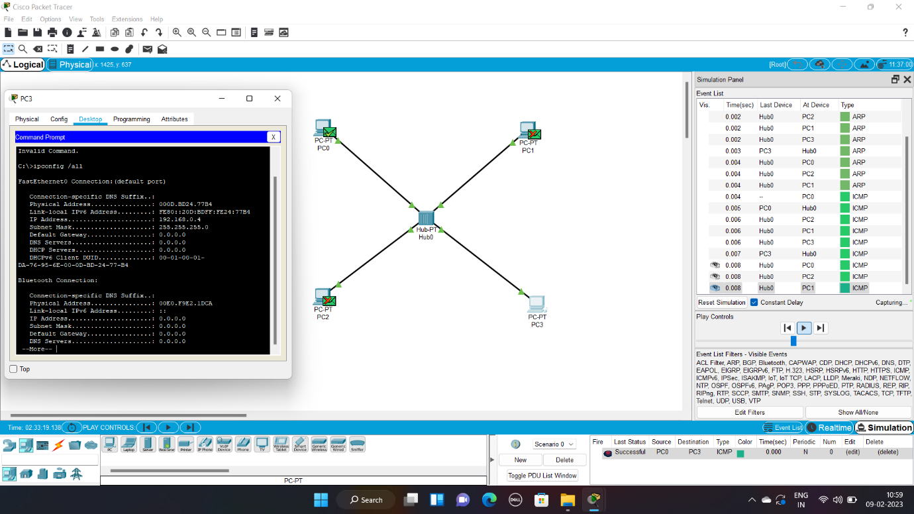

2. Design and Configuration of Star Topologies using Packet Tracer 192111560

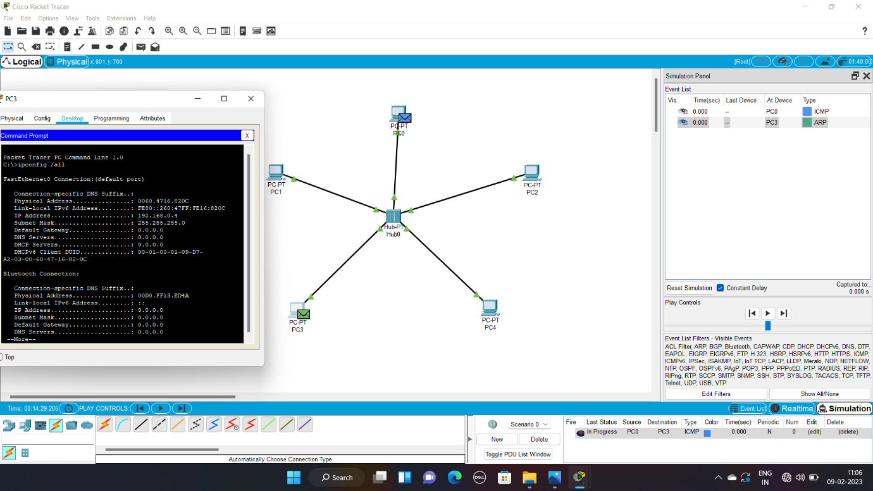

3. Design and Configuration of BUS Topologies using Packet Tracer 192111560

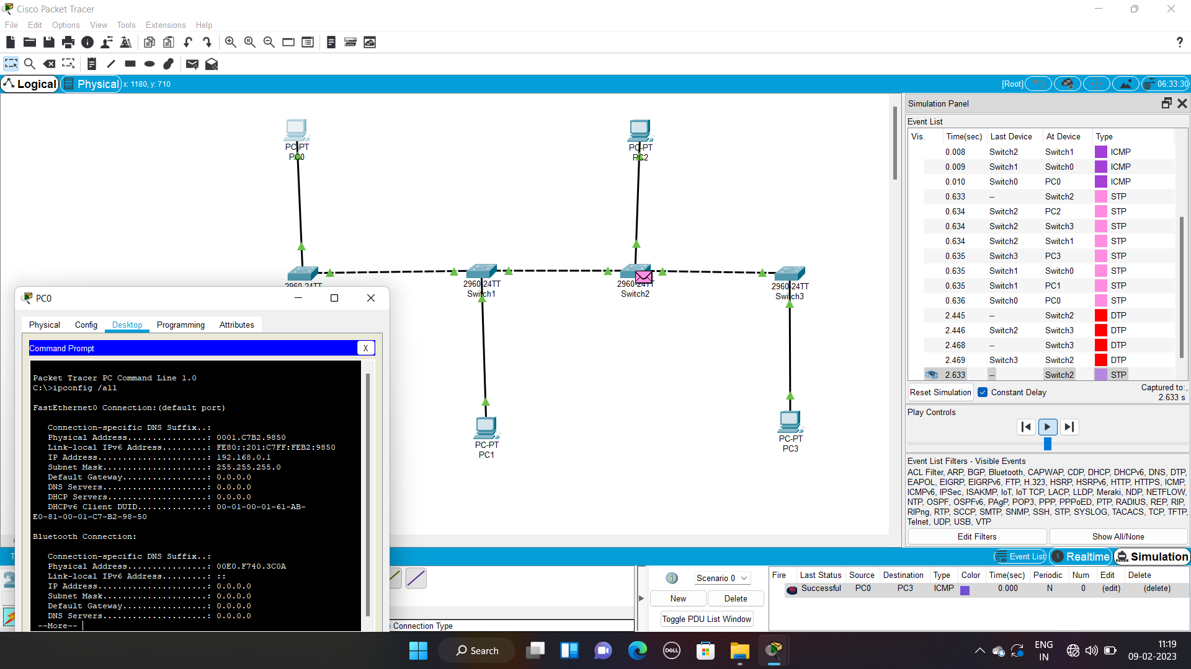

4. Design and Configuration of RING Topologies using Packet Tracer 192111560

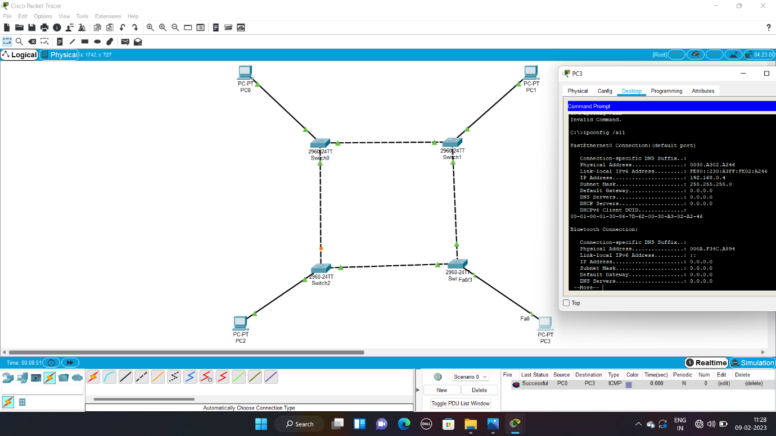

5. Design and Configuration of Mesh Topologies using Packet Tracer 192111560

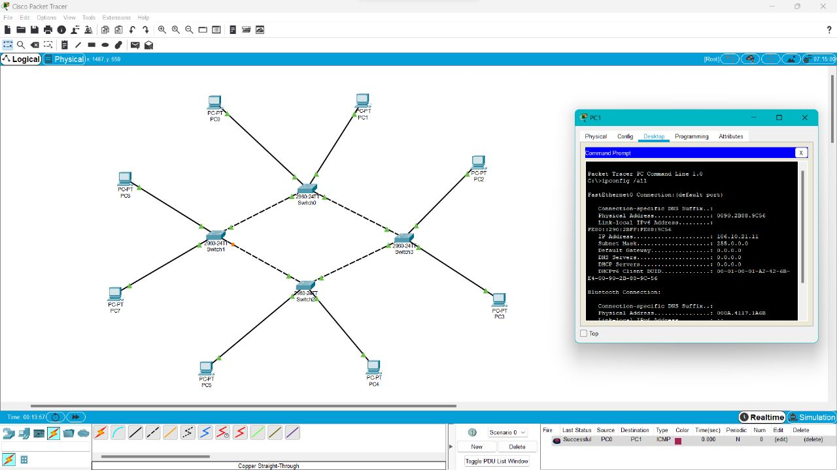

6. Design and Configuration of Tree Topologies using Packet Tracer 192111560

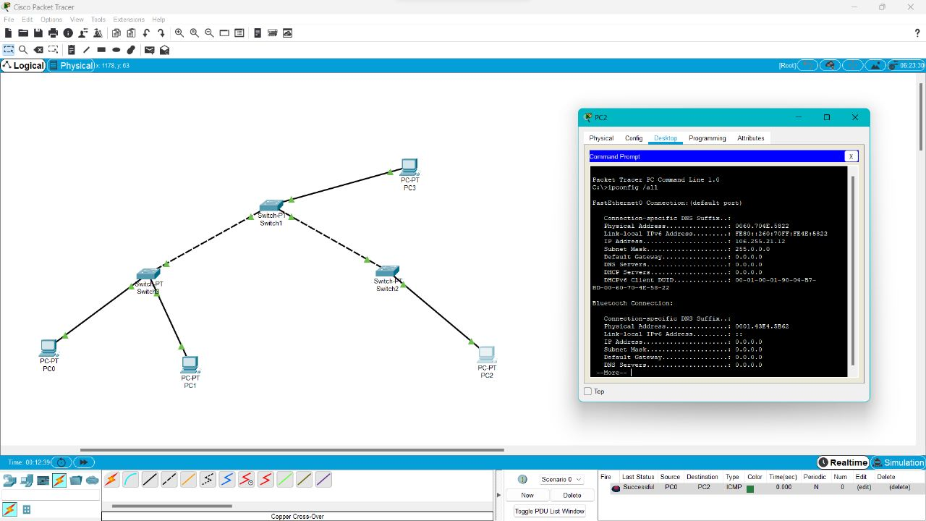

7. Design and Configuration of Hybrid Topologies using Packet Tracer 192111560

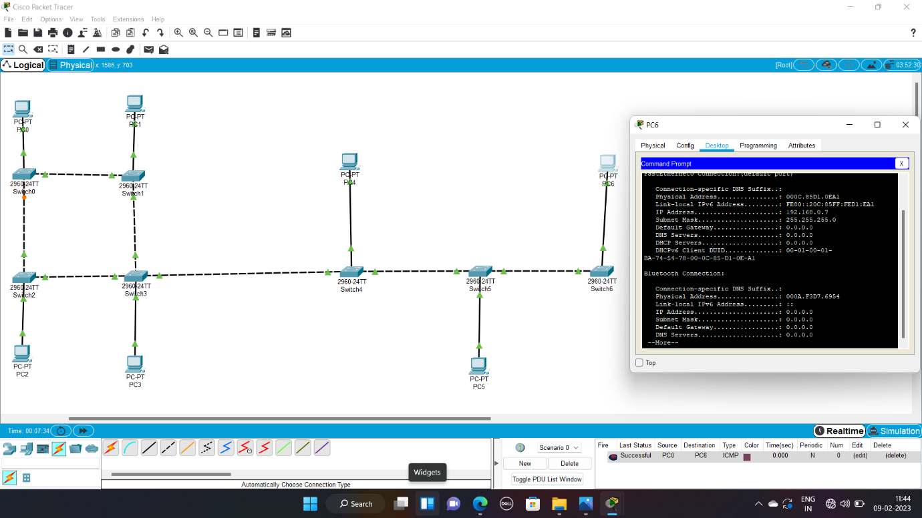

8. Data Link Layer Traffic Simulation using Packet Tracer 192111560 Analysis of ARP

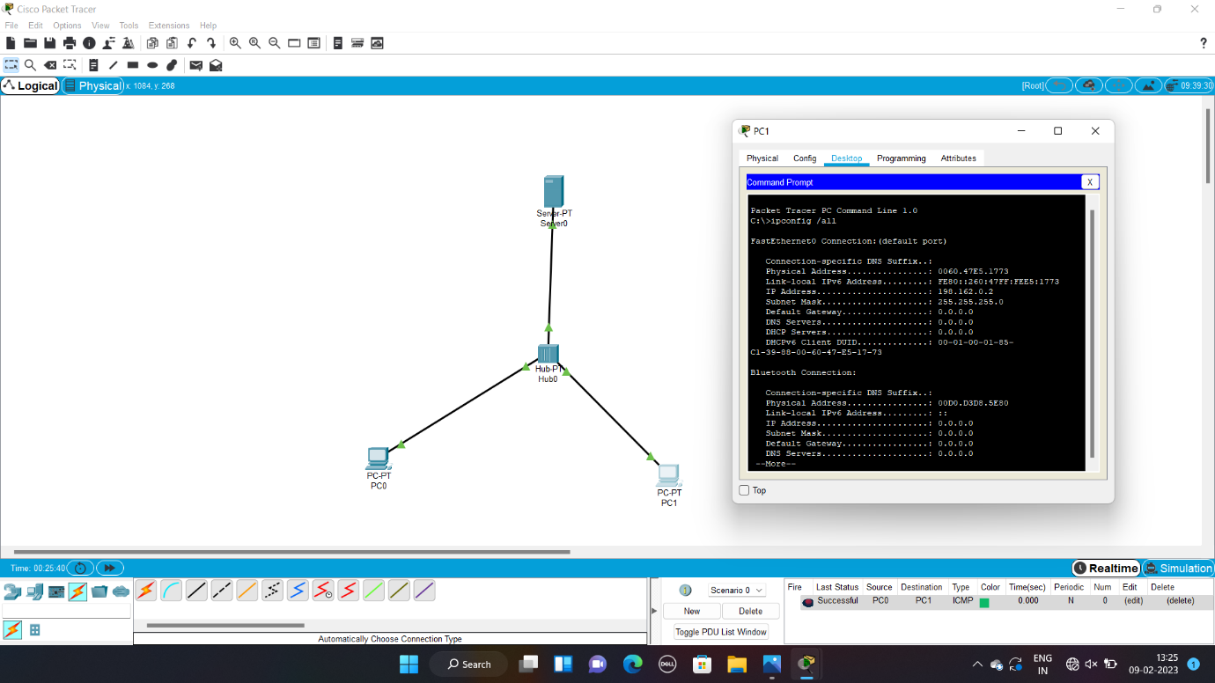

9. Data Link Layer Traffic Simulation using Packet Tracer 192111560 Analysis of LLDP

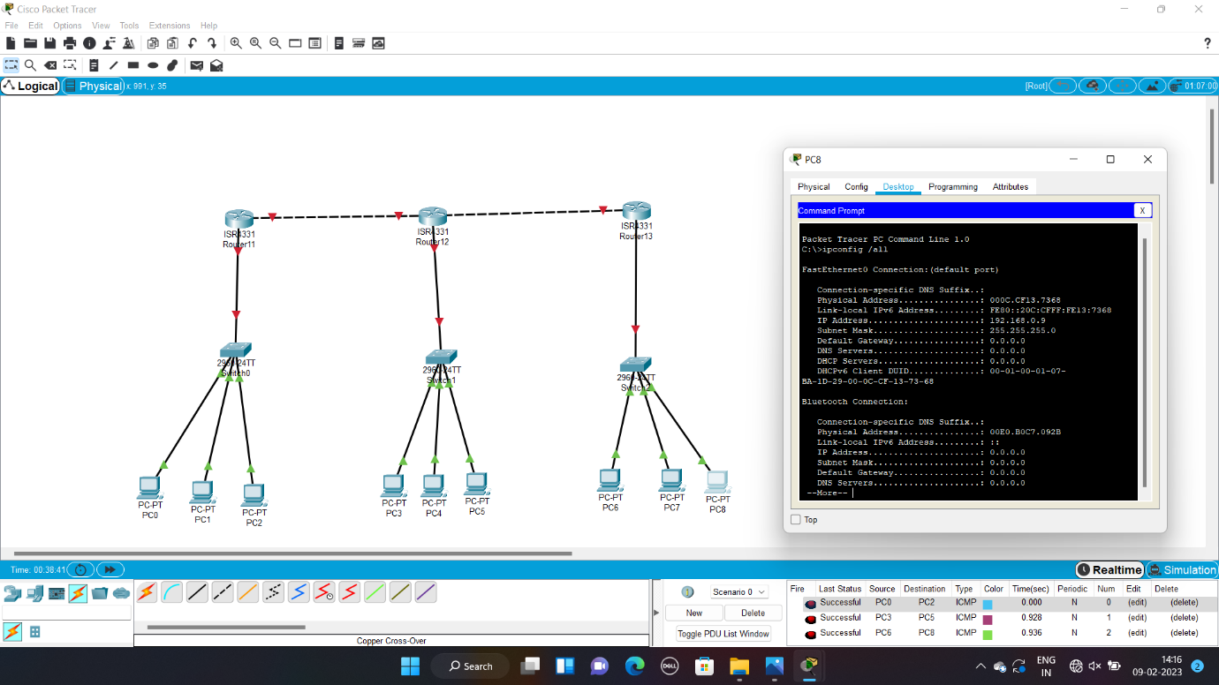

10. Data Link Layer Traffic Simulation using Packet Tracer 192111560 Analysis of CSMA/CD & CSMA/CA

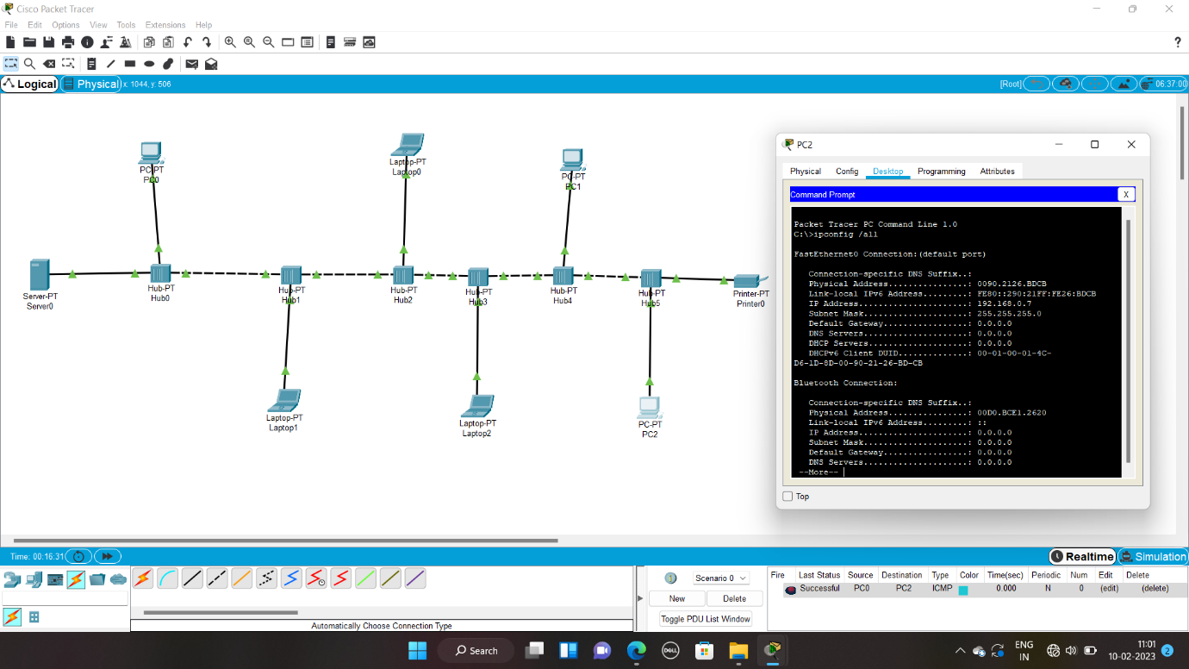

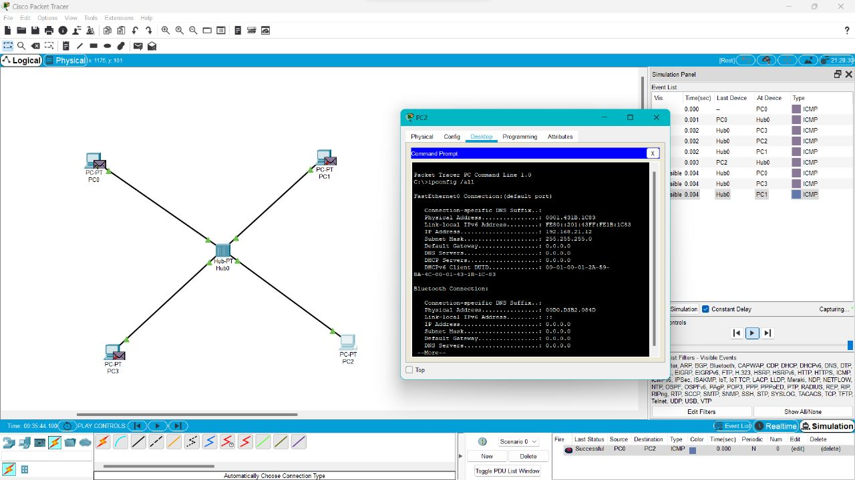

11. Implementation of Bit stuffing mechanism using C

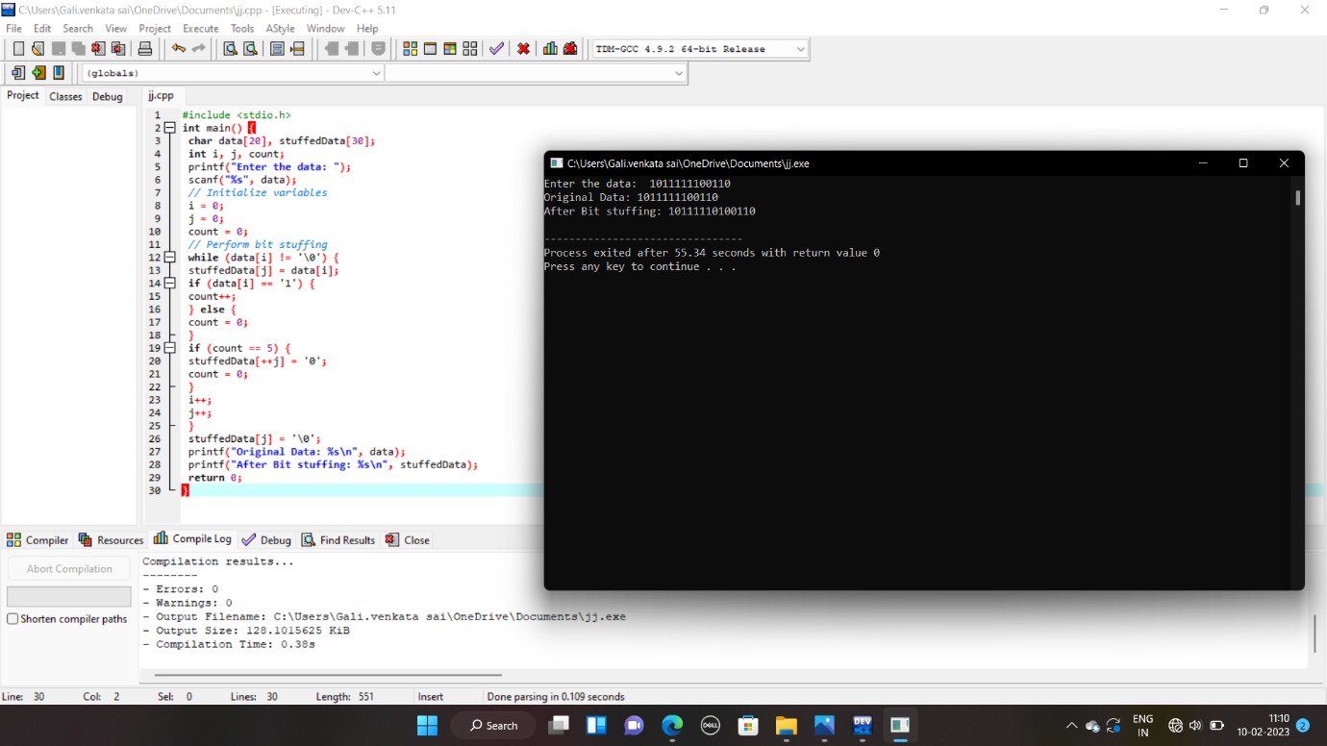

12. To design the two different networks with Static Routing techniques using Packet Tracer 192111560

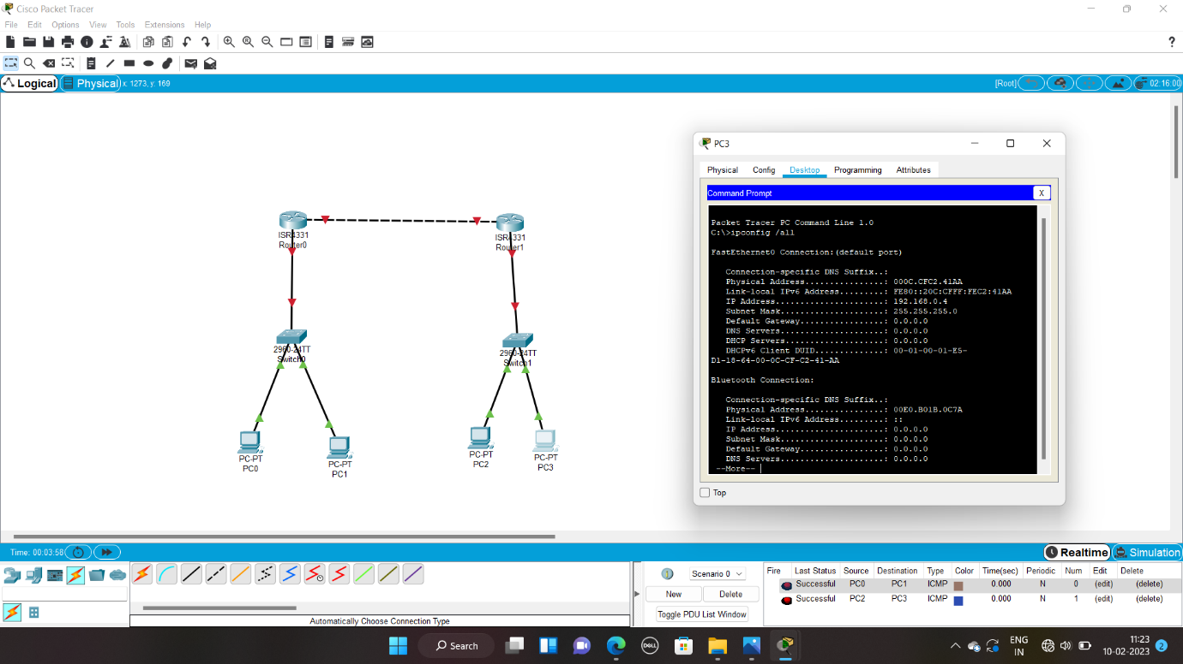

13. To design the Network with Dynamic Routing using Packet Tracer 192111560 (Distance vector & OSPF)

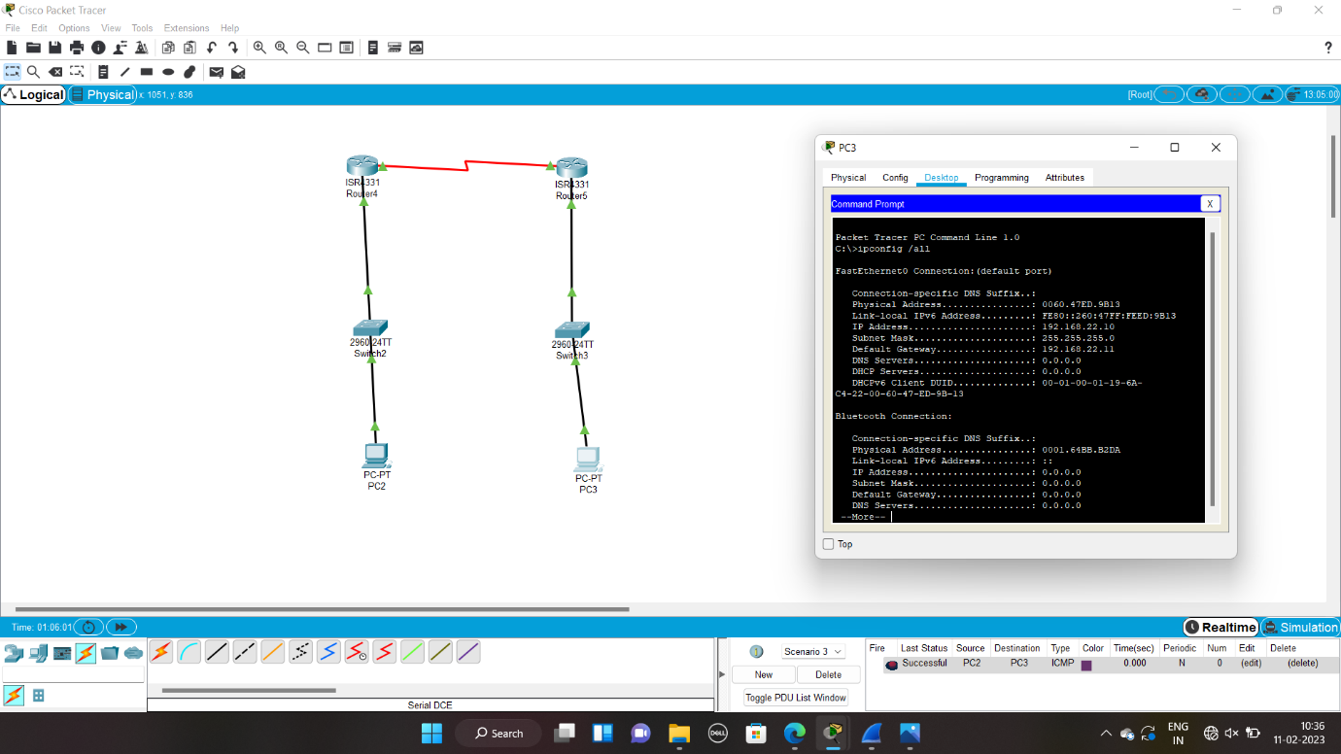

14. Design the Functionalities and Exploration of TCP using Packet Tracer 192111560

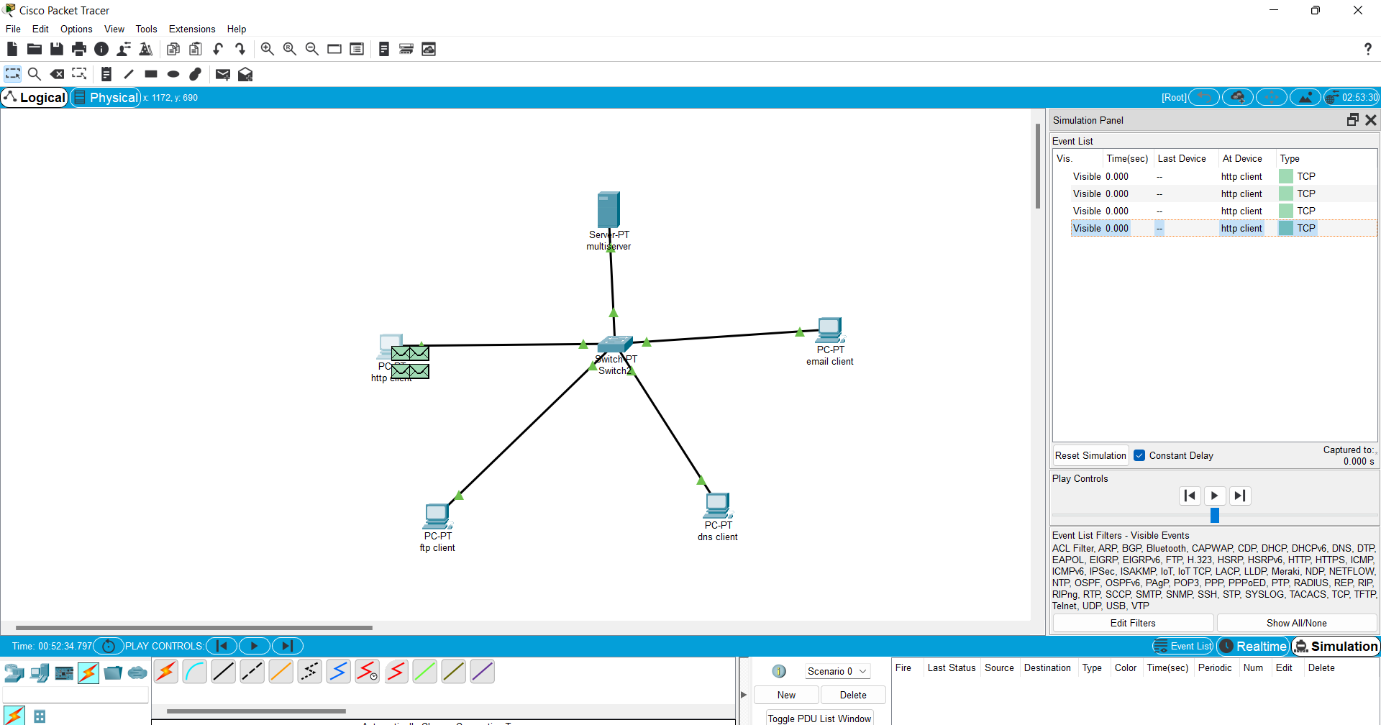

15. Design the Functionalities of Exploration UDP using Packet Tracer 192111560



16. Design the network model for Subnetting – Class C Addressing using packet tracer 192111560

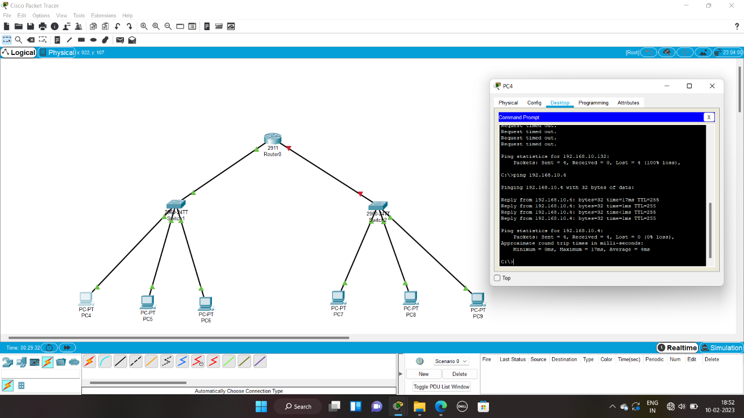

17. Implementation of server – client using TCP socket programming192111560



18. Implementation of server – client using UDP socket programming192111560



19. Simulating X, Y, Z Company Network Design and simulate using Packet Tracer 192111560

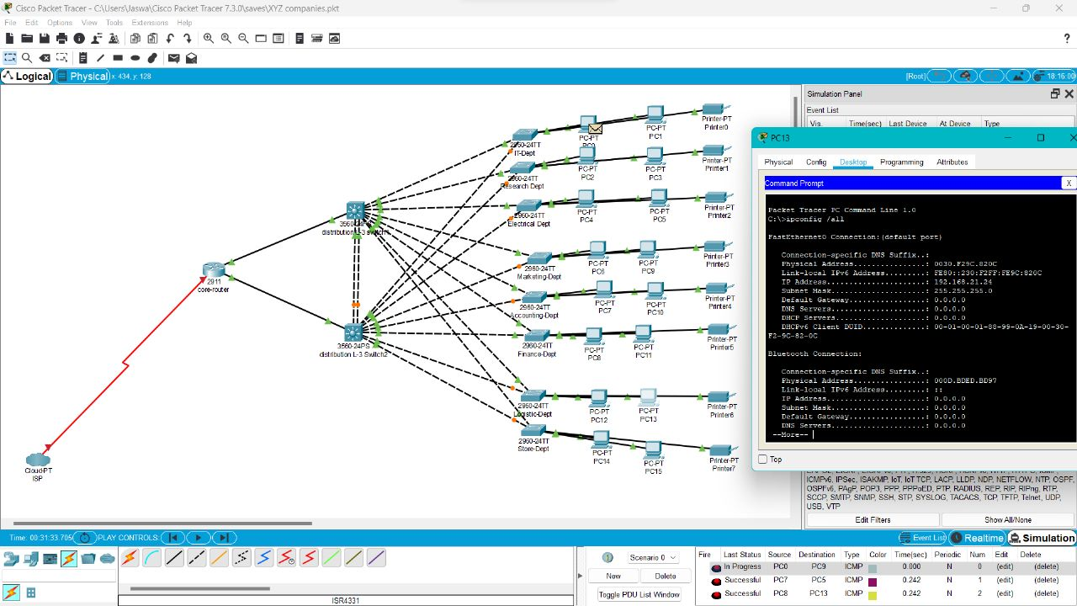

20. Configuration of DHCP (dynamic host configuration protocol) in packet tracer 192111560

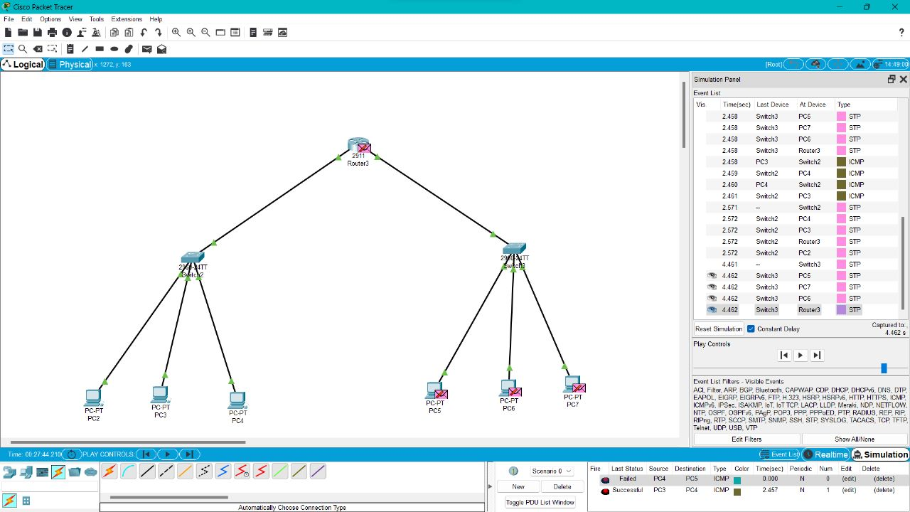

21.Make a Computer Lab to transfer a message from one node to another to design and simulate using Cisco Packet Tracer 192111560

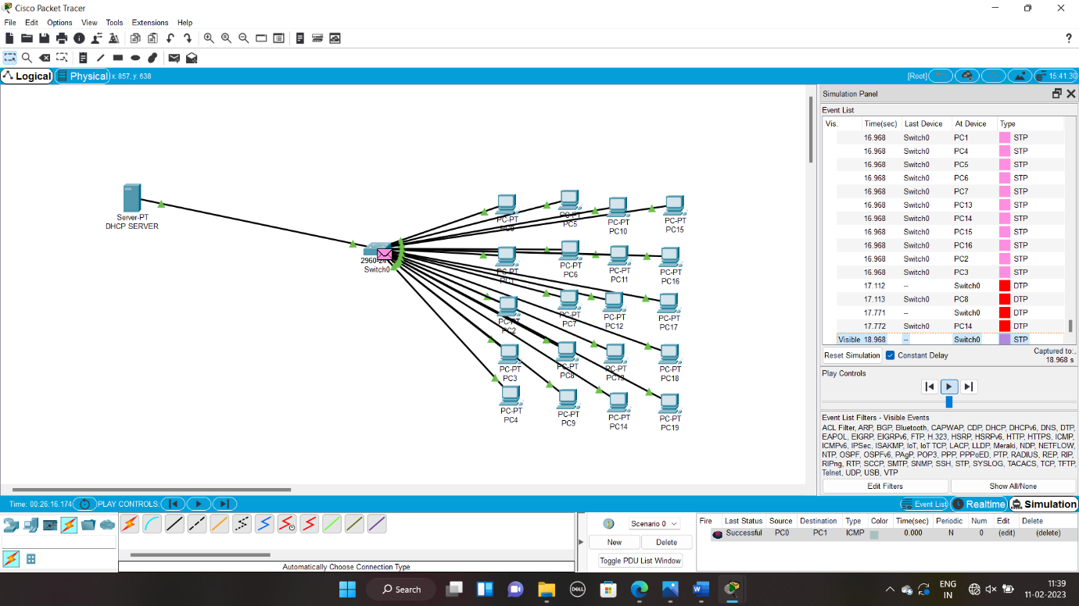

22. Transport layer protocol header analysis using Wireshark- TCP192111560

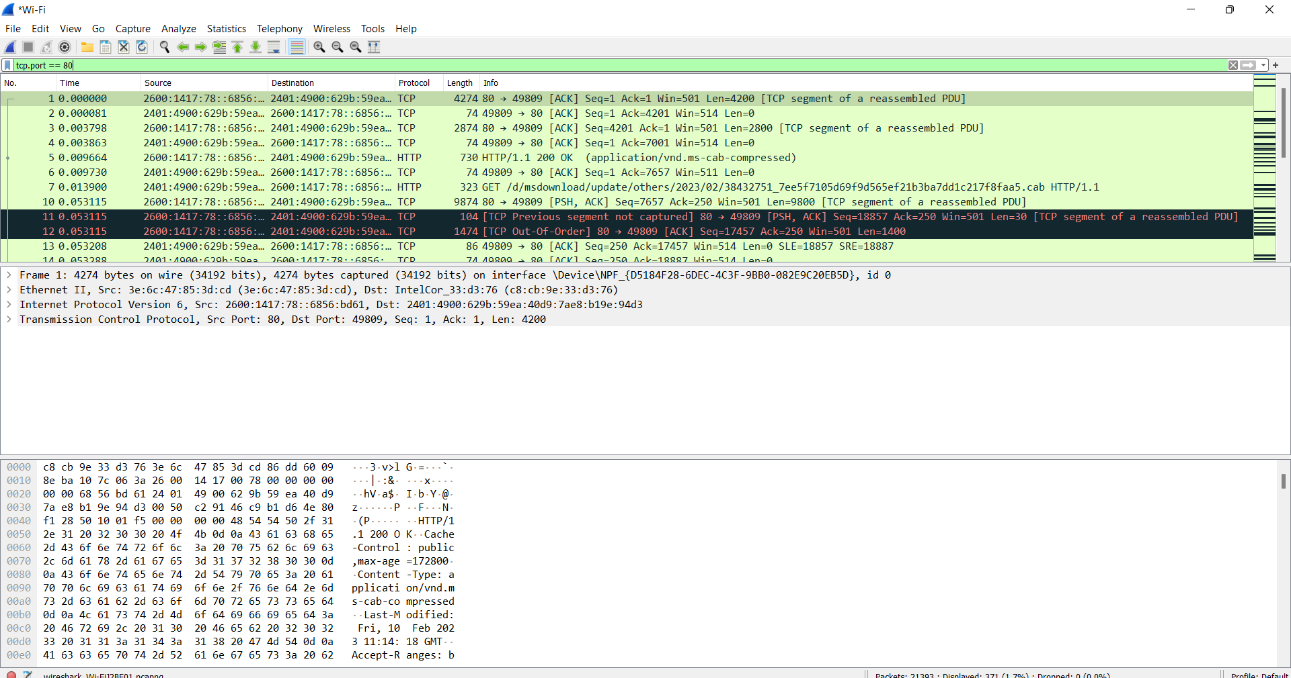

23. Network layer protocol header analysis using Wireshark – SMTP192111560

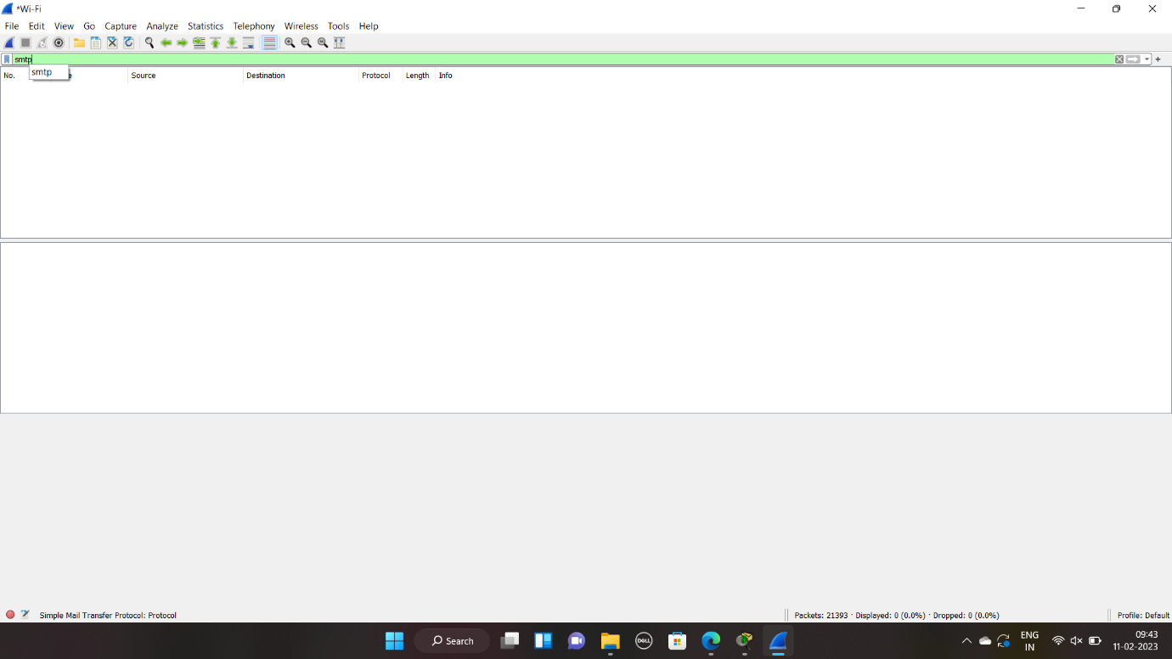

24. Network layer protocol header analysis using Wireshark – ICMP192111560

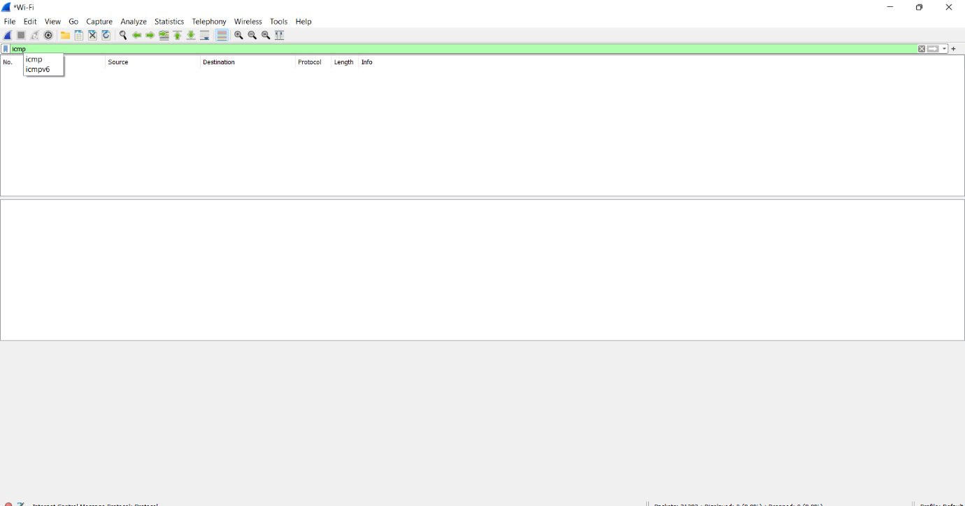

25. Transport layer protocol header analysis using Wireshark – UDP192111560

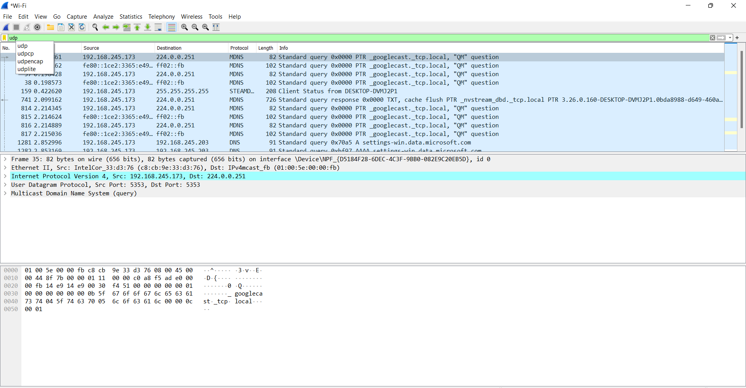

26. Network layer protocol header analysis using Wireshark – ARP192111560

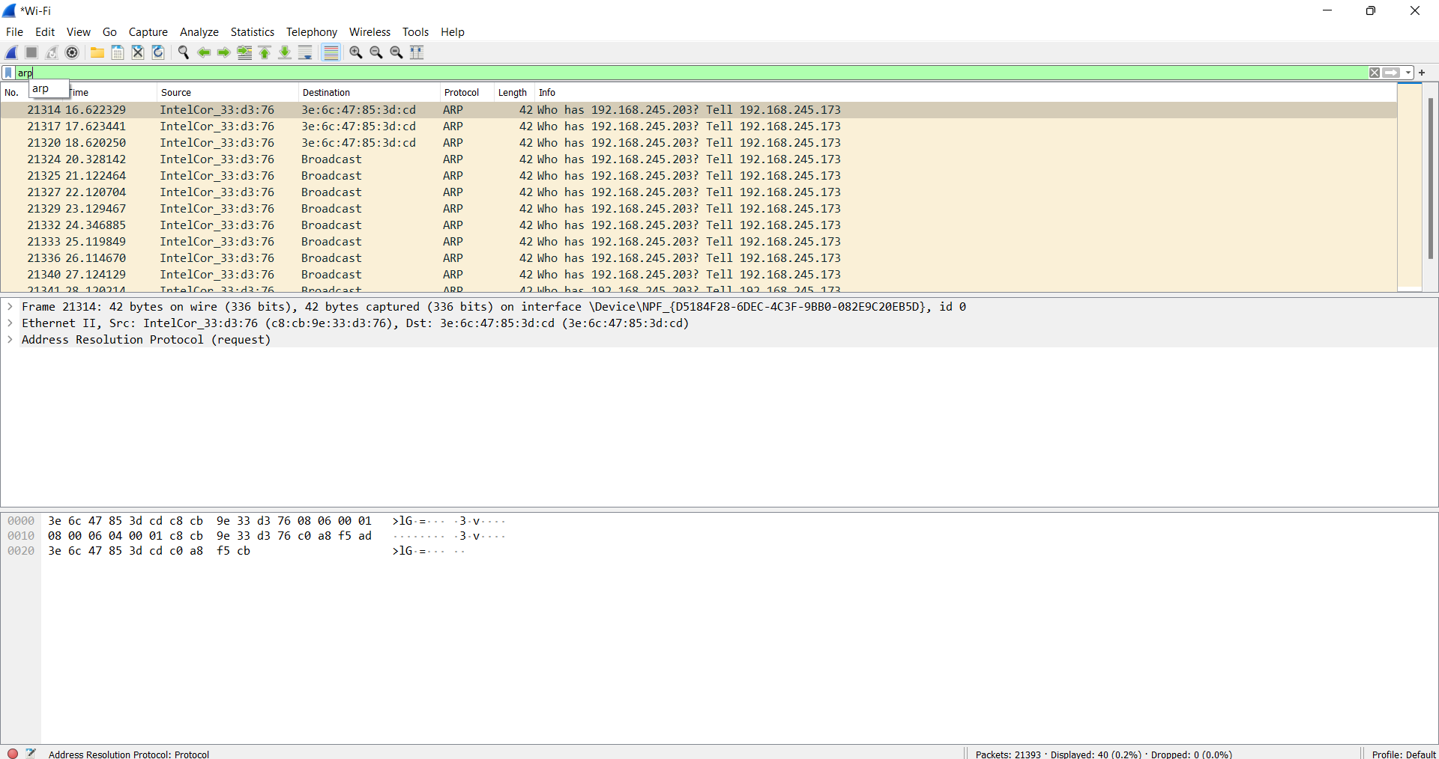

27. Network layer protocol header analysis using Wireshark – HTTP192111560

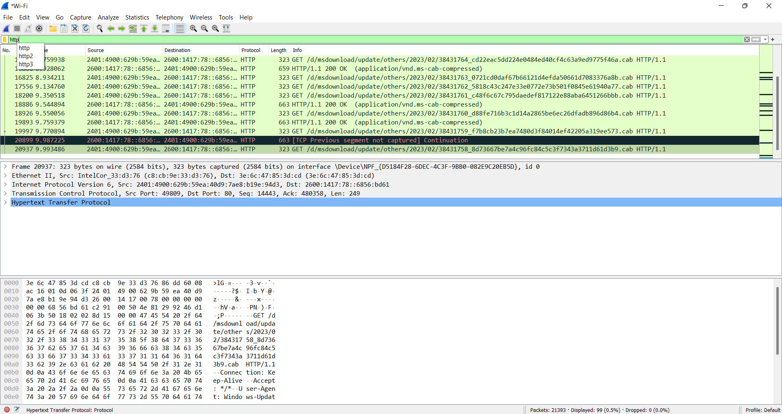

28. Demonstration of PING operation using ICMP in Wireshark192111560

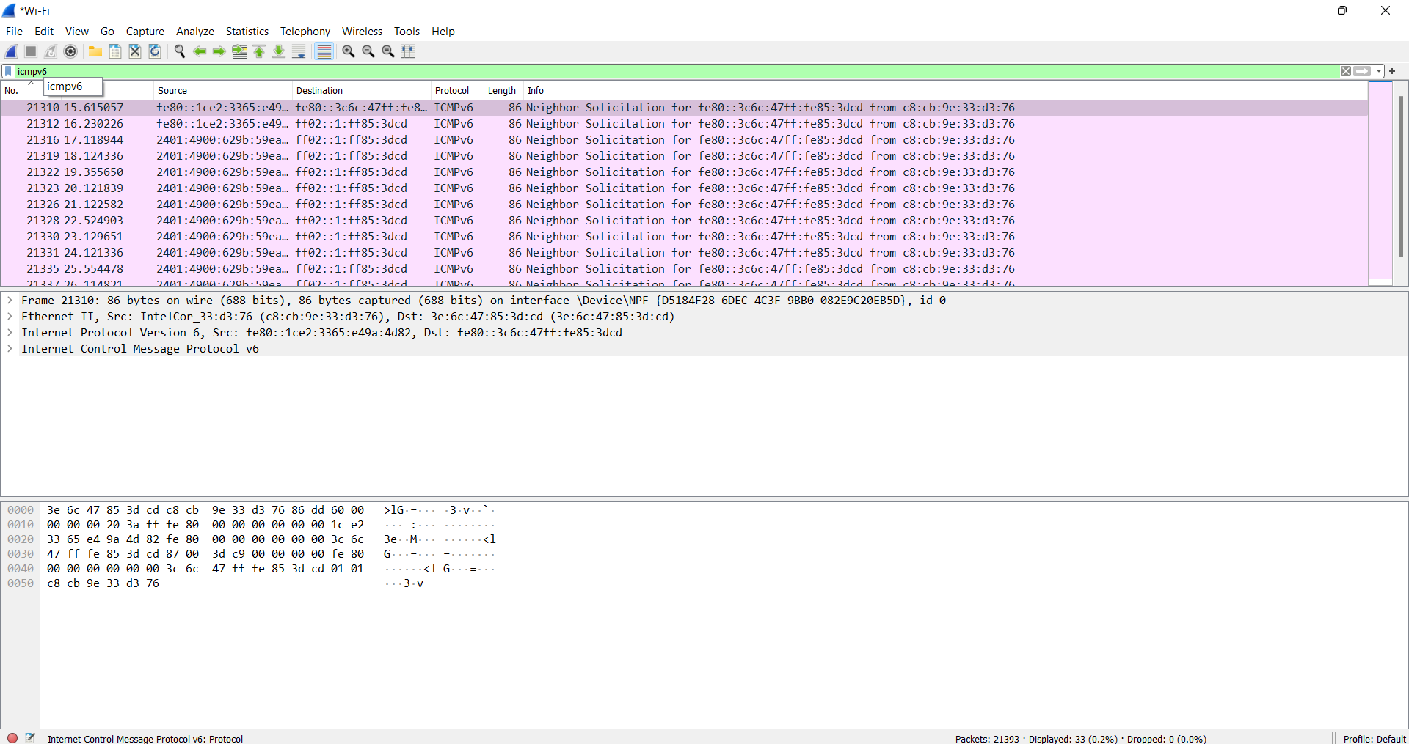

29. IOT Based Smart Home Using Cisco Packet Tracer 192111560

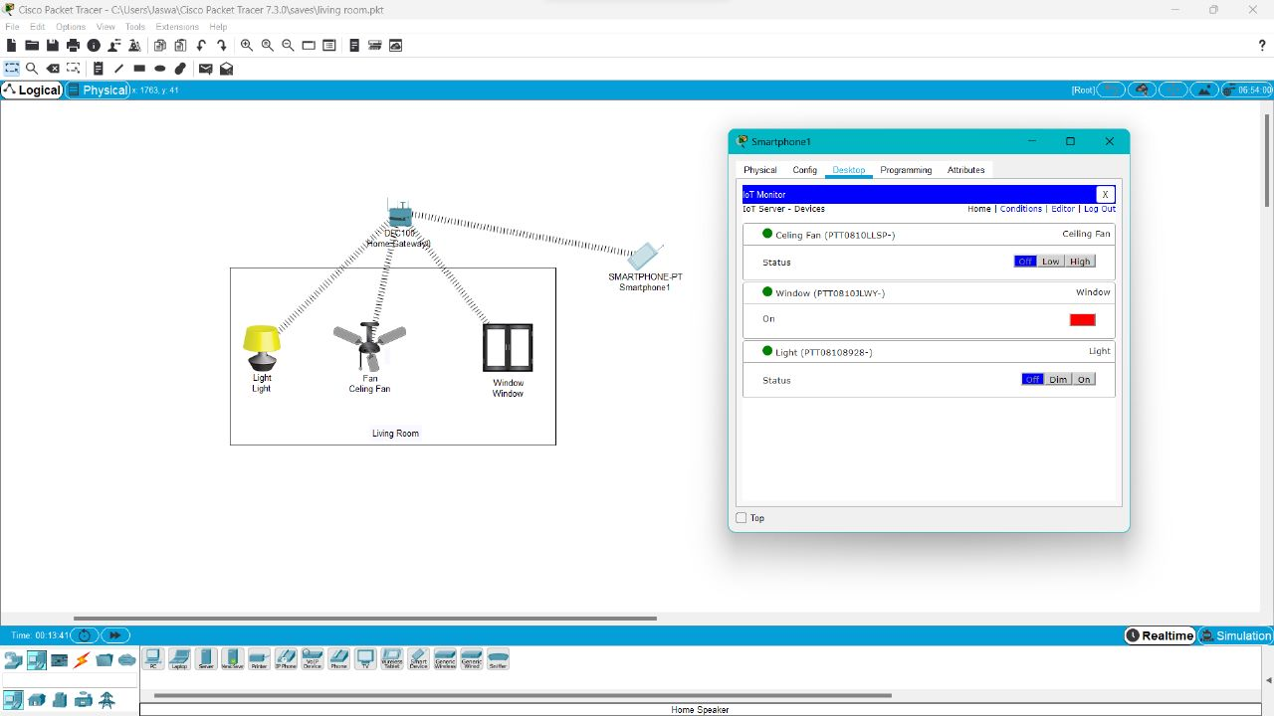

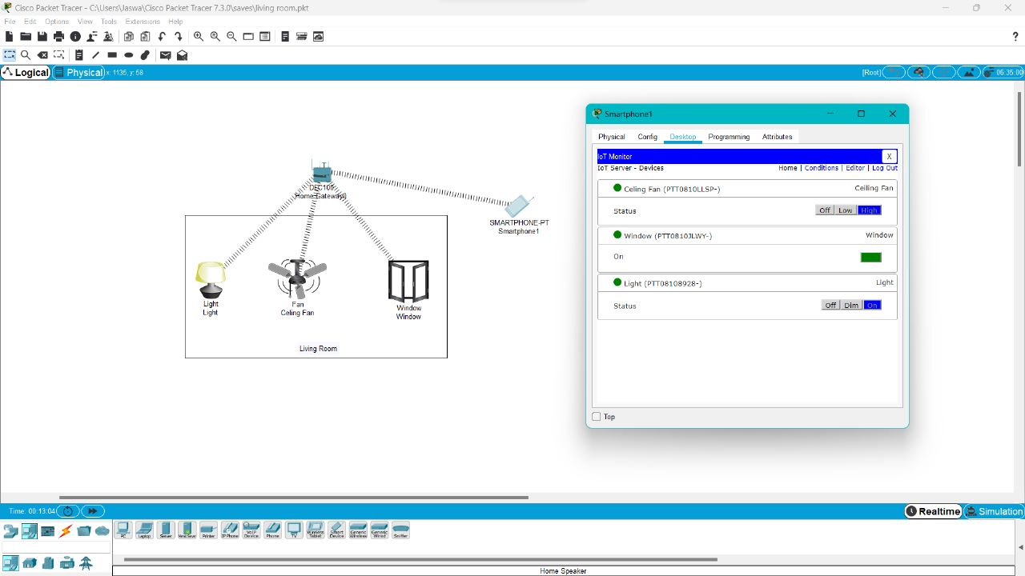

30. Smart Garden in Cisco Packet Tracer 192111560

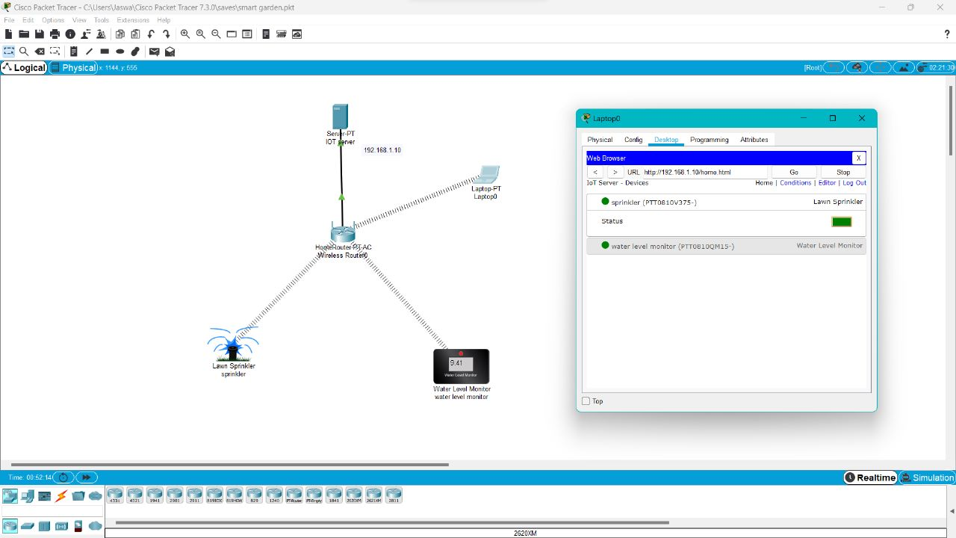

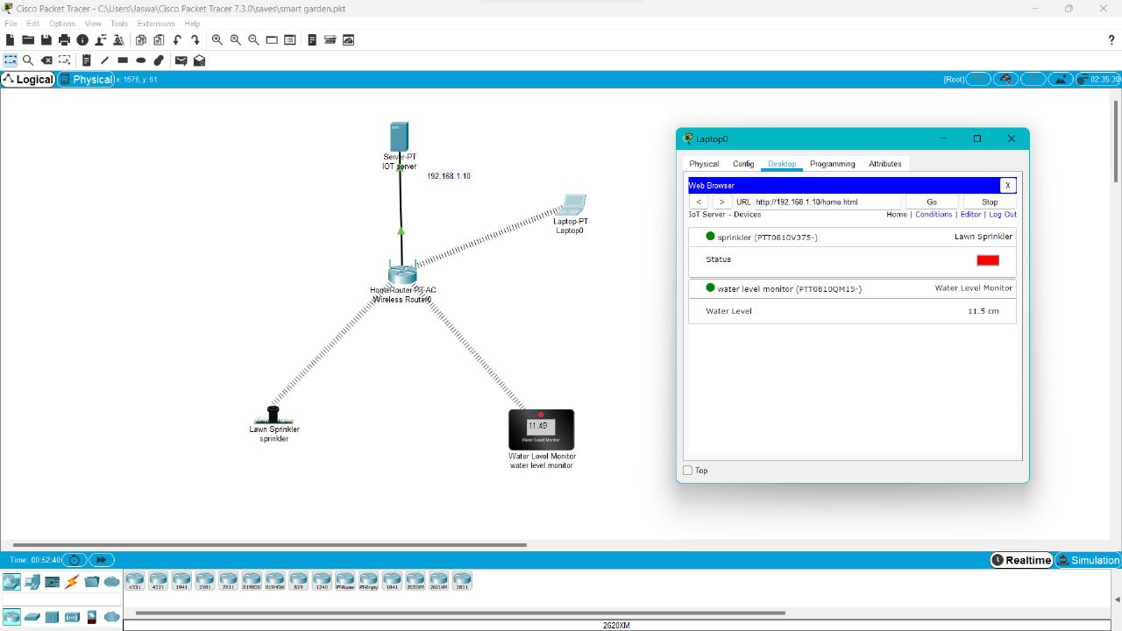

31. IOT Devices in Networking Using Cisco Packet Tracer 192111560

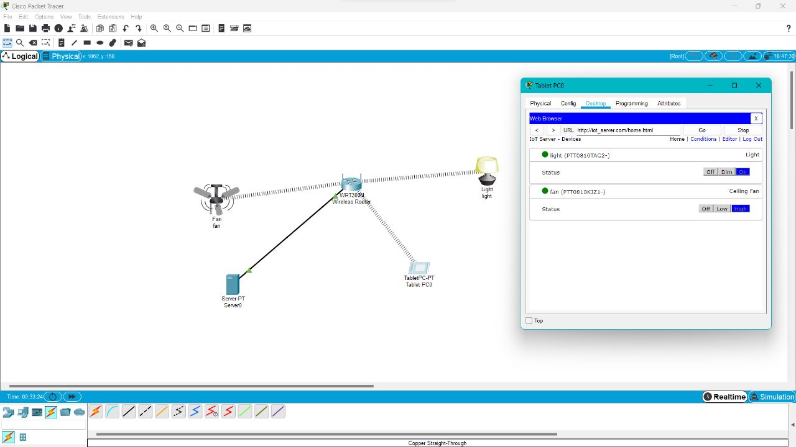

32. Control of Fan, Light, Window & Application of Using Cisco Packet Tracer 192111560

